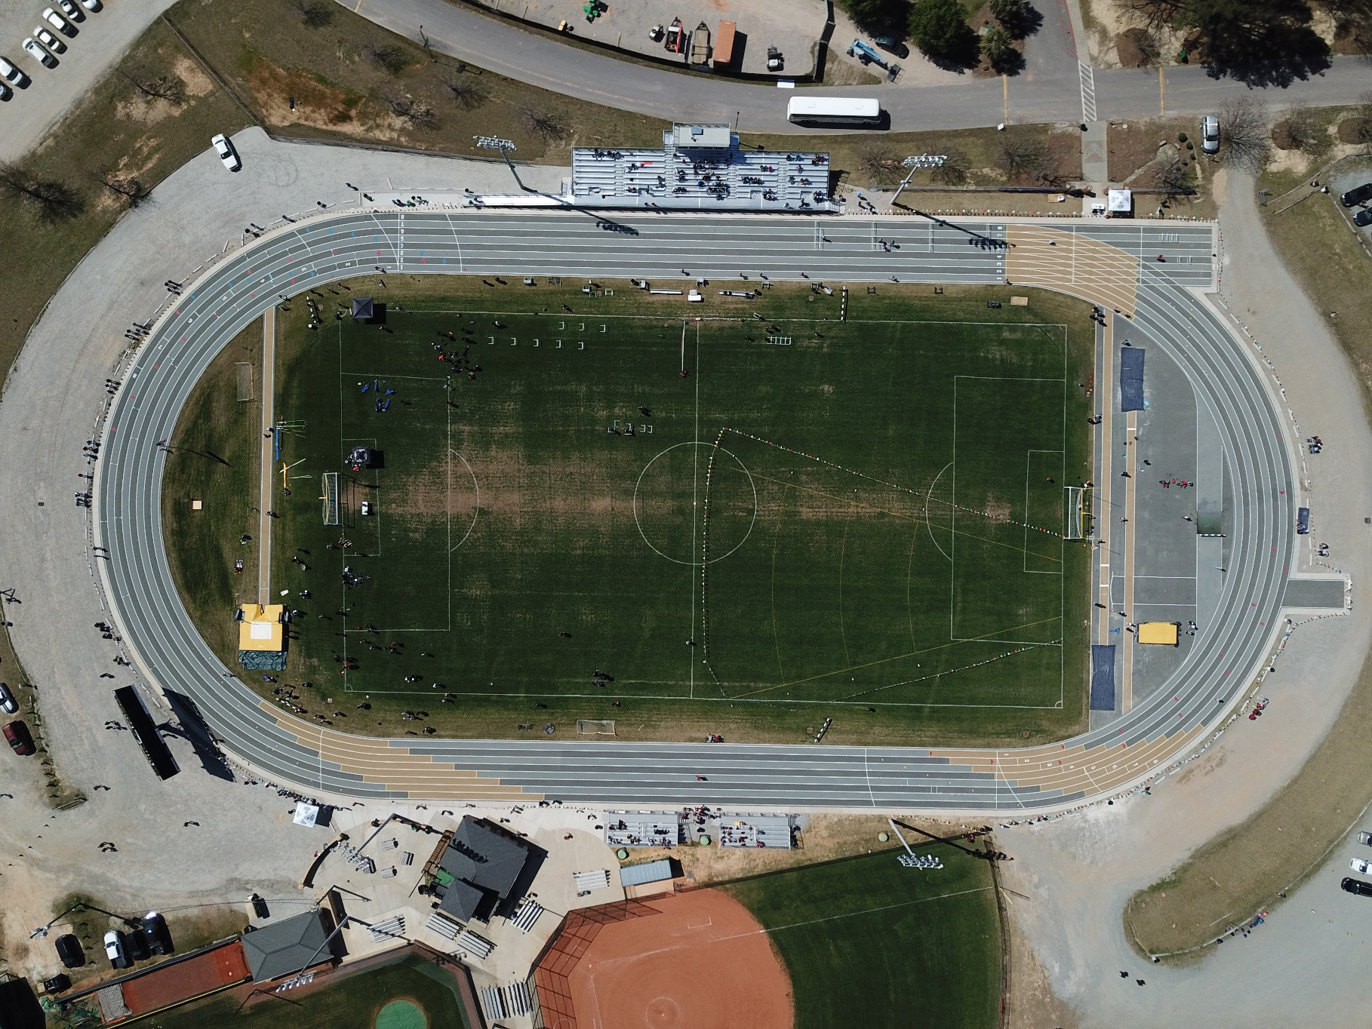

**Track Map**

**Main Entrance**

**Concessions**

**Event Check-in**

**Jumps**

**Pole Vault**

**Warm Up Area**

**Throwing Area**

**Team Tent Area**