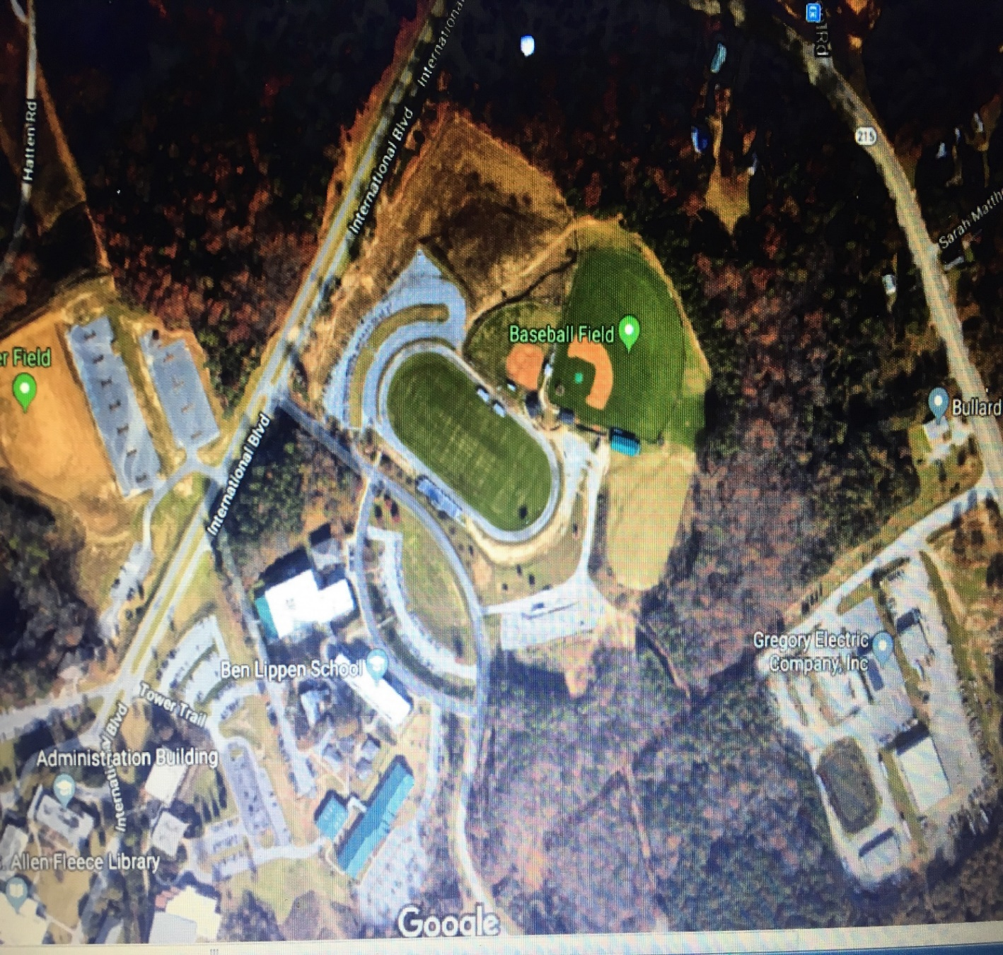

**Spectator Parking**

**Bus Parking**

**Spectator Parking**

**Bus Parking**

**Team Tent**

**Team Tent**

**Warm Up**

**Spectator Parking**

**Campus Map**

**(parking, warm-up, team tent)**