Flucos MS XC course
~ 2 miles
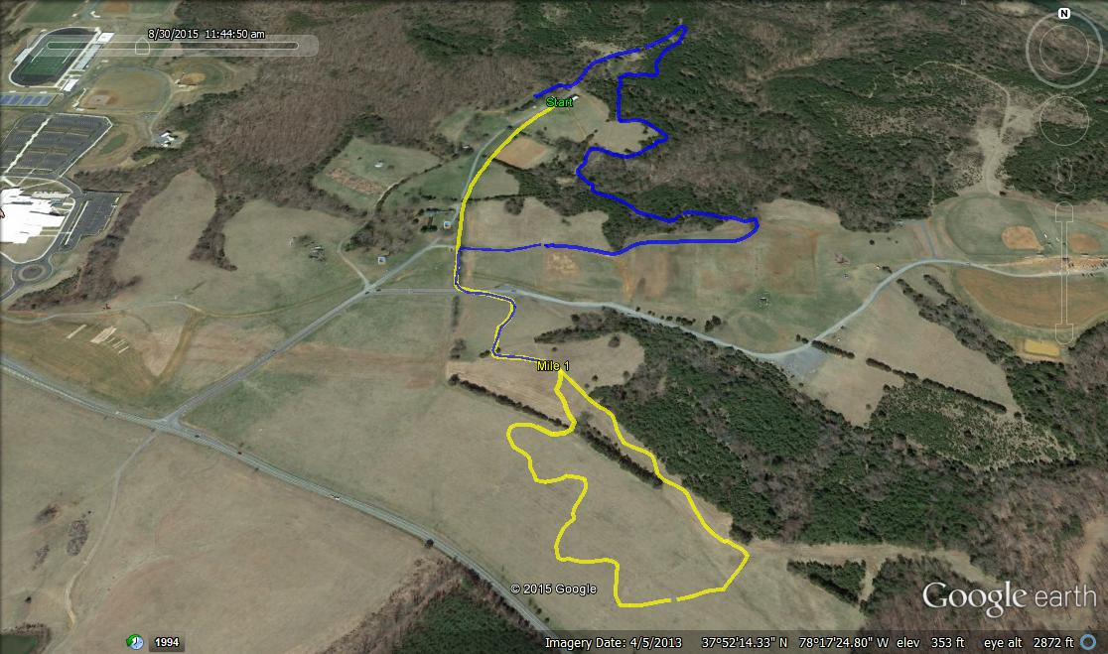
@ Pleasant Grove
Death
Meadow

