Flucos XC 5k course
@ Pleasant Grove
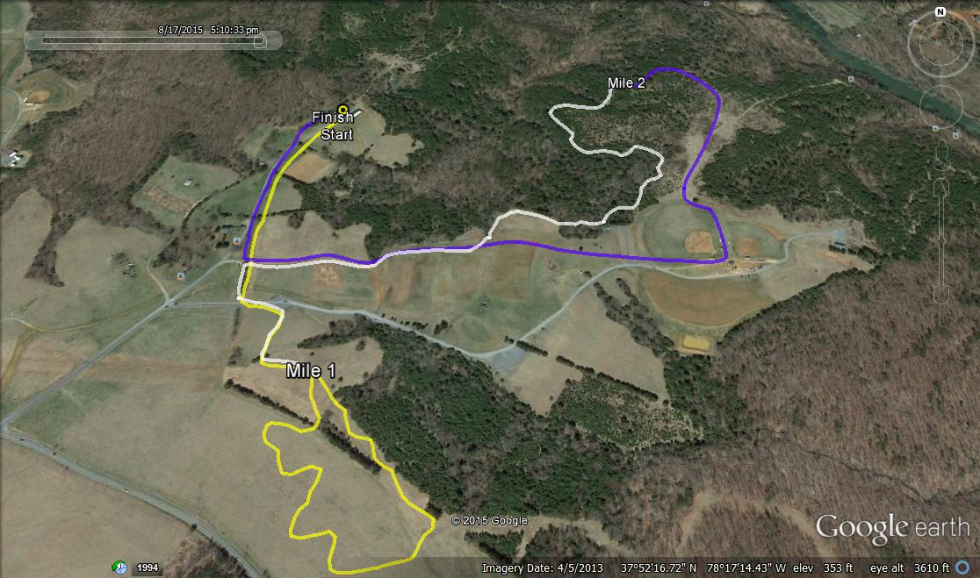
Death
Meadow

