3A Region D Cross Country Championship Meet 2018
Hosted by Alleghany High School
October 30, 2018

Site of Meet: Jackson River Sports Complex
870 W Edgemont Dr. Covington VA 24426

Directors: Jeremy Bartley (304.952.8007), Karen Staunton (540.863.1800) Kstaunton@alleghany.k12.va.us

Preview Meet: Alleghany Invitational September 29 http://va.milesplit.com/meets/303056/info#.W1h_NtJKjIU
If you and your team will be attending please register on Milestat.com
All Registration will be done on Milestat.com

Meet Schedule
2:00 Course Opens
3:30 Coaches Meeting at the Amphitheater
4:00 Boys Championship Race
4:30 Girls Championship Race
5:00 JV Race (no numbers or official results)
Awards to follow

Timing:
The meet will be chip timed by Run Roanoke

Scoring and Uniforms
We will follow the NFHS Rules Book for Scoring and Uniforms. See the NFHS T&F/XC rules book if you need. Spikes are recommended for this course.

Submitting Entries
All entries will be done through milestat.com.
ALL ENTRIES ARE DUE BY Saturday, October 27.
Information for registering online can be found at www.milesplit.us/pages/Online_Meet_Reg_Instructions.
Awards: Awards will be presented as follows:
Top boy’s and girl’s team
Certificates to the top 15 finishers in each race

State Meet:
The top 3 teams will progress to the 3A State meet
The top 5 individuals not on these teams will advance to the 3A State meet
Coaches will enter their team or individuals online on milestat
The VHSL State Entry form paper copy should be emailed or given to Coach Jeremy Bartley at jbartley1@alleghany.k12.va.us
State entry form: https://www.vhsl.org/cross-country/ click under Resources.

Results
Will be posted at the meet and will be sent to Milestat.com.
Concessions
Gatorade, Water, Fruit, Snacks, and lunch items will be available for purchase.
Multiple Restrooms will be available on site
Team Area
Teams will have a designated area. We ask that everyone be respectful of our host site and clean up after ourselves when we leave (trash bags will be provided).
Water Coolers will be available for athletes before and after the race.
Directions to Jackson River Sports Complex
From the East: I-64 West to Exit 14 in Covington. Take a right and travel 1 mile on S. Durant Road/Jackson Street. Take a left on S. Rayon Drive and cross a bridge over the Jackson River. After bridge, road veers to the left and Jackson River Sports Complex will be on the left. The Sports Complex is 1.4 miles off of I-64.
From the West: I-64 East to Exit 14 in Covington. Take a right and travel 1 mile on S. Durant Road/Jackson Street. Take a left on S. Rayon Drive and cross a bridge over the Jackson River. After bridge, road veers to the left and Jackson River Sports Complex will be on the left. The Sports Complex is 1.4 miles off of I-64.
Parking Information
Parking will be available on site. There will be a $5.00 fee per vehicle Spectator Fee (team buses and vans exempt). Buses can park in the bus lot, if the lot is full, busses can drop teams off at the Sports Complex and then park at Jackson River Enterprises at the park entrance.
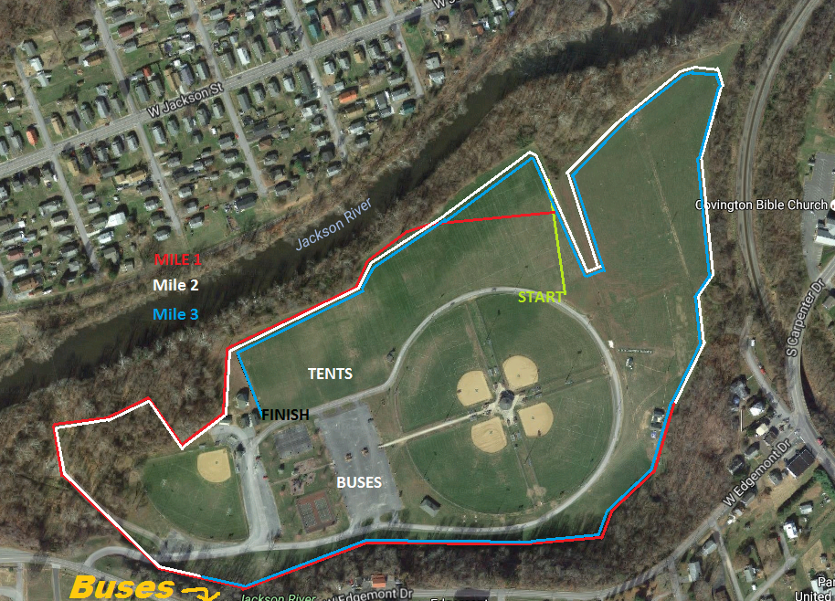
QUESTIONS
Please contact Jeremy Bartley
Email: jbartley1@alleghany.k12.va.us
304.952.8007

